ITD – ITIN Power Apps Training · Student Lab Guide
Lab 03: Build the Availability Entry Form
Management Workforce Availability App — letting employees submit their status
Estimated time | 50–65 minutes
Difficulty | Beginner — no prior Power Apps experience required
Prerequisite | Lab 00, Lab 01, and Lab 02 completed
You will build | A working Edit Form on My Availability that validates, submits, and resets

Lab Overview
In this lab you will build the screen employees actually use day to day: a form where they record their availability for a given date. You will add the required fields, make the form automatically fill in the signed-in user's name and email, check that required fields are completed before saving, and show a confirmation message when the submission succeeds.

Objectives
- Add an Edit Form to the My Availability screen.
- Configure its fields and default values.
- Default the employee name and email to the signed-in user, where supported.
- Validate that required information is filled in before submitting.
- Submit the form and show a success notification.
- Reset the form after submission.

Required fields for this form
- Work Date
- Availability Status
- Team or Unit
- Manager Email

Power Apps concepts used in this lab
Concept | What it means
Edit Form | A control that generates input fields for a record automatically, based on a data source.
Data card | One field inside a form — its label, input control, and validation, grouped together.
NewForm() | Puts a form into “new record” mode with blank/default values.
SubmitForm() | Saves the form's current values back to the data source.
ResetForm() | Clears a form back to its default values after a successful submit.
User().FullName / User().Email | Returns the signed-in user's display name or email address.
Notify() | Shows a small banner message to the user (success, error, warning, or information).

Part A — Add the Edit Form
- In the Tree view, click “My Availability” to select that screen.
- Click the “Insert” tab, then click “Forms” (or find it under a “Layout” / “Input” category, depending on your version).
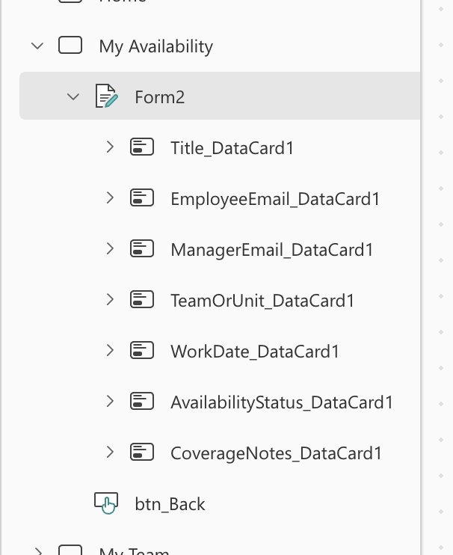
- Choose “Edit” from the form type options. A blank Edit Form control appears on the canvas.
- Rename the form using the name box above the canvas (or right-click it in the Tree view → Rename). Type:
frmAvailability
- With the form selected, set its Data source in the Properties pane (right side) to WorkforceAvailability.
💡 TIP
If the Properties pane doesn't show a “Data source” option immediately, look for a prompt directly on the canvas that says “Connect to data” — both lead to the same setting.

Add the fields
- With the form selected, click “Edit fields” in the Properties pane.
- Click “+ Add field” and add each of the following,
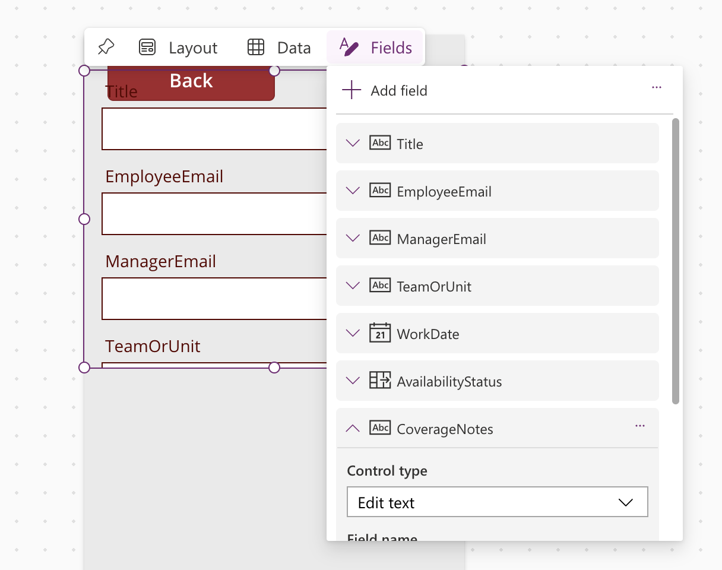
- clicking “Add” after selecting each one:
  - Title (Employee Name)
  - EmployeeEmail
  - ManagerEmail
  - TeamOrUnit
  - WorkDate
  - AvailabilityStatus
  - CoverageNotes
Close the Edit fields panel once all seven are listed and appear as data cards on the canvas.
✅ CHECKPOINT
Checkpoint: The My Availability screen should now show seven labeled input fields stacked vertically: Employee Name, Employee Email, Manager Email, Team or Unit, Work Date, Availability Status, and Coverage Notes.

Part B — Default the Employee Name and Email
Rather than making employees type their own name and email every time, you will default those two fields to whoever is currently signed in, using the User() function.

Step 1: Find the inner input control of the Employee Name card
- In the Tree view, find the data card for Employee Name (it will be nested under frmAvailability) and click the small arrow beside it to expand it.
- Click the child control inside it — usually named something like “DataCardValue1” — this is the actual text box the user types into.
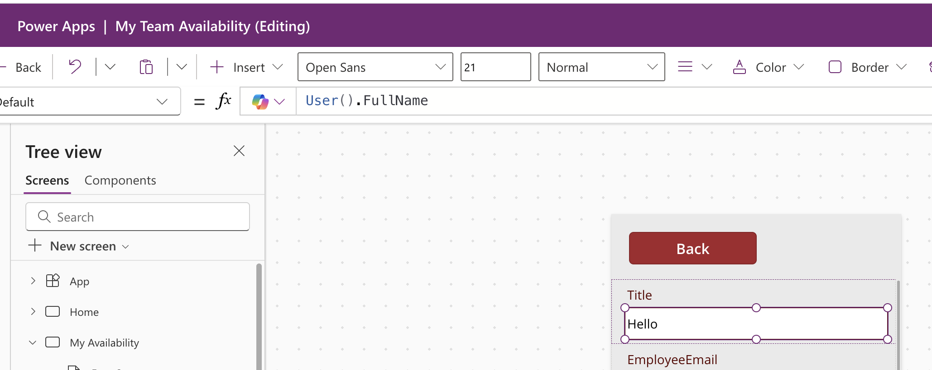
- In the formula bar, set the property dropdown to “Default” and type:
User().FullName

Step 2: Repeat for the Employee Email card
- Expand the Employee Email data card in the Tree view and select its inner input control.
- Set its Default property (formula bar) to:
User().Email

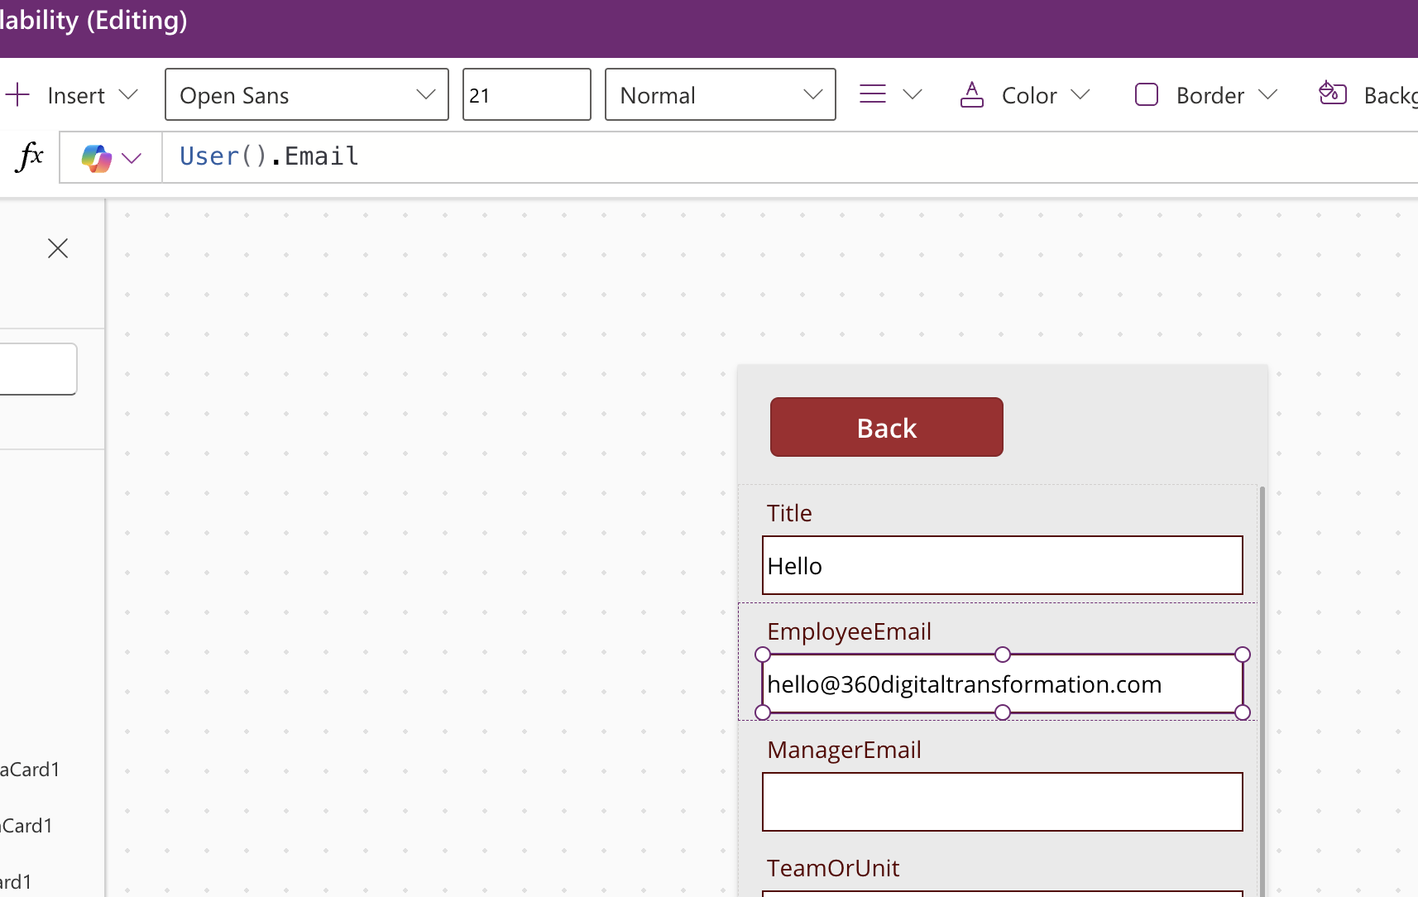
ℹ NOTE
“Default” pre-fills a value but still lets the user change it. If you want the field to be locked so it can never be edited, select the data card itself (not the inner control) and set its DisplayMode property to DisplayMode.View.
💡 TIP
“Where supported” matters here: User().FullName and User().Email rely on your organization's directory information being available to Power Apps. If either shows blank in Preview, that's expected in some training tenants — the field will simply stay editable so the user can type their name and email manually.

Part C — Start a New Entry Automatically
So the form is always ready for a fresh entry when a user opens My Availability, set the screen to reset the form every time it's visited.
- Click on an empty area of the My Availability screen's canvas (not on the form) so the screen itself is selected — the Tree view should highlight “My Availability.”
- In the formula bar, set the property dropdown to “OnVisible.”
- Type:
NewForm(frmAvailability)
- Press Enter to save.
ℹ NOTE
The source lab notes also describe a combined pattern you'll see used elsewhere in the app — for example on a dedicated “New Entry” button:
NewForm(frmAvailability); Navigate(scrMyAvailability, ScreenTransition.Fade)

Either pattern is valid — OnVisible keeps this lab simple, since My Availability only ever needs to open in “new entry” mode.

Part D — Validate and Submit the Form
Add a Submit button that checks the two most critical required fields before saving, and blocks the save with a clear message if they're missing.

Step 1: Name the key input controls
The validation formula needs to refer to the Work Date and Availability Status input controls by name, so rename them first.
- Expand the Work Date data card in the Tree view and select its inner input control (the date picker).
- Rename it (name box above the canvas) to:
dteWorkDate
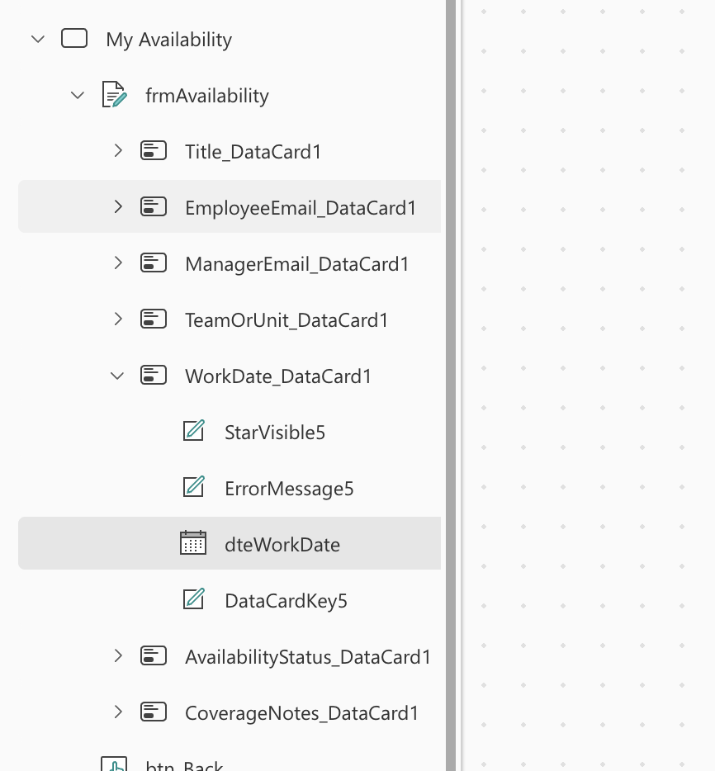
- Expand the Availability Status data card and select its inner input control (the dropdown).
- Rename it to:
drpAvailabilityStatus
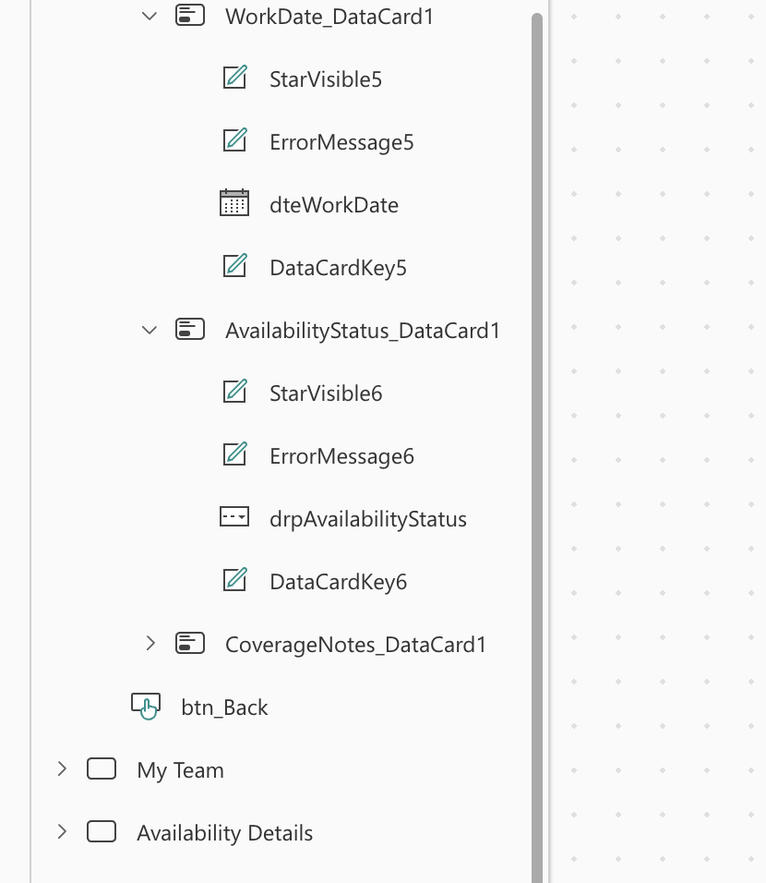

Step 2: Add the Submit button
- Click the “Insert” tab, then “Button,” and place it below the form.
- Set its Text property to:
Submit
- With the button selected, set its OnSelect property (formula bar) to:
If(
IsBlank(dteWorkDate.SelectedDate) ||
IsBlank(drpAvailabilityStatus.Selected.Value),
Notify("Complete all required fields before submitting.", NotificationType.Error),
SubmitForm(frmAvailability)
)

ℹ NOTE
In plain language: if either the date or the status was left blank, show a red error message and stop. Otherwise, save the record. You can extend this same If() pattern later to check Team or Unit and Manager Email too.

Part E — Confirm Success and Reset the Form
Every form has an OnSuccess property
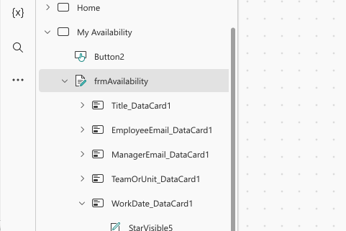
that runs automatically right after SubmitForm() saves successfully. Use it to show a confirmation, clear the form, and return the user to Home.
- Select the form (click frmAvailability in the Tree view).
- In the formula bar, set the property dropdown to “OnSuccess.”
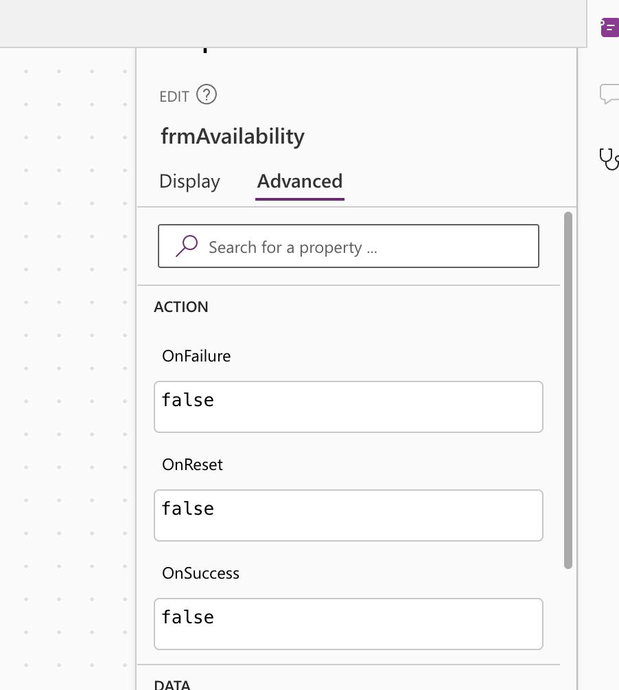
- Type:
Notify("Your availability was submitted.", NotificationType.Success);
ResetForm(frmAvailability);
Navigate(scrHome, ScreenTransition.Fade)

- Press Enter to save.
💡 TIP
OnSuccess only runs after a real, successful save — it will not run if your Submit button's validation blocked the save, which is exactly the behavior you want.

Part F — Test the Form
- Click the Play button (▶), or press F5, to preview the app.
- Navigate to My Availability. Confirm Employee Name and Employee Email are already filled in (or blank, per the note in Part B).
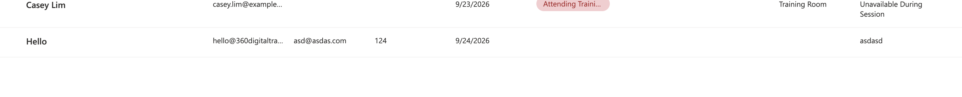
- Leave Work Date and Availability Status blank and click Submit.
→ Expected result: a red error notification appears and nothing is saved.
- Fill in a Work Date, choose an Availability Status, fill in Team or Unit and Manager Email, then click Submit.
→ Expected result: a green success notification appears, the form clears, and you land back on Home.
- Navigate to My Team (from Lab 02) and
- confirm your new record appears in the gallery alongside the five sample records.
- Exit preview mode (Esc) and save your app (Ctrl+S).
⚠ IMPORTANT
If Submit does nothing and shows no error, double-check the exact names dteWorkDate and drpAvailabilityStatus from Part D, Step 1 — a mismatched name is the most common cause.

Lab 03 Complete — Checkpoint
✅ CHECKPOINT
You should now have a fully working entry form: required-field validation, a success notification, an automatic reset, and a return to Home — with your test record visible in My Team. In Lab 04 you will help managers search and filter that data by date, status, and team.

Self-check questions
- Which form property runs automatically right after a successful SubmitForm()?
- What is the difference between setting a Default value and setting DisplayMode.View on a data card?
- Why must dteWorkDate and drpAvailabilityStatus be renamed before the validation formula will work?

Next: Lab 04 — Build the My Team View

